Measuring Planck’s Constant with 1) LEDs And 2) Photoelectric effect

- LED’s
We will use LEDs (Light Emitting Diodes) to determine Planck’s constant. The experiment allows for a simple setup where the measurement of the “turn on” voltage of an LED is determined for various color LEDs. For this, we will need to determine the threshold voltage at which the current begins to flow in the forward direction for a certain diode. An ideal diode behaves as a step function such that when the voltage is increased, the current jumps from zero to non-zero (causing the diode to light) at a particular voltage called “threshold voltage”. Unfortunately, such idealized situations do not occur so we must delve into some theory behind I vs. V for diodes and therefore, we must make a careful empirical call regarding what is meant by threshold voltage.
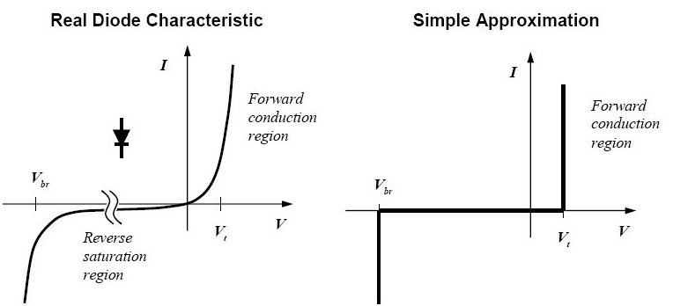

Learning goals
At the end of this lab you should be able to:
- Explain the current-voltage characteristic of a non-ideal LED
- Measure Planck’s constant
- Calculate some physical parameters of an LED fitting the Shockley equation

Introduction and background
Ultimately, since there are no “ideal” diodes with a perfectly defined step for turn on (threshold voltage), therefore we must make a call as to what to consider threshold voltage. Fortunately, we have precision equipment (much better than seeing the diode light up with our bare eyes) to determine when current begins to go forward through the diode. We’ll use 4.00nA as our measured threshold determinations, i.e., when the current reaches that value, we will say that the diode is conducting (turned on). Note, the specific value of “4.00nA” is chosen here somewhat arbitrarily, but with educated information. The change in threshold voltage by going to 3.00nA or 5.00nA or even 20nA is extremely small compared to the bandgap voltage itself. The 4.00nA is comparable to typical dark currents (thermal noise background) seen in many such detectors---so a value has been selected that is just measurable and beyond any background current offsets. This can be observed experimentally---even without a specific theory driven number for the “turn on” current. The specific details for that “turn on number” are beyond the scope of this experiment, so we use a very good estimate for close enough

All Light Emitting Diodes are light detectors in addition to light emitters. This means that when exposed to ambient light, there is a back current (reverse biased current---through the diode the wrong way) generated by exposure to light. In general, this might not be noticeable, but since we are viewing such small currents, the “back current” due to ambient light can be large enough to completely overwhelm the roughly 4nA signal we are looking for. To eliminate this effect, the diodes have been taped over with black tape (check, cover, and probably a good idea to work in dim room—see if it matters). If you have time, you should remove the tape and observe what happens to the current as you bring your cell phone flashlight in near the diodes. This should explain why we need to use sensitive ammeters and not just our bare eyes to find out when a LED is turned on. Additionally, you can also see that such diodes can be turned into good optical detectors (the photogates you have used -or made- in other courses is just one example.)

In addition to the normal “threshold voltage” and the offset current due to “light detection”, there is also an additional offset due to thermal conduction of electrons called “thermionic emission”. We’ll note these offset effects, but ultimately, they will not change our determination of Planck’s constant significantly as long as the offsets can be minimized and are approximately the same for each diode.

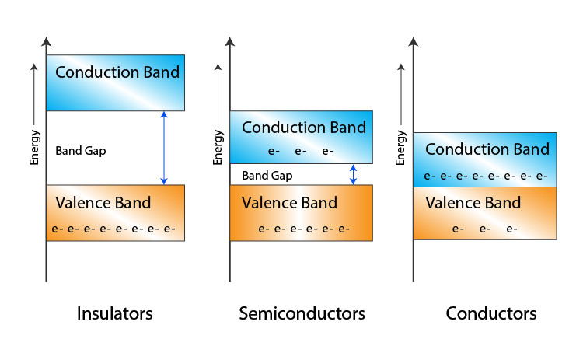
How does an LED work? When light is incident upon an atom at just the right energy to match the spacing between two atomic resonances (energy levels), the light may be absorbed, and an electron will “jump” to a higher excited level. In solid semiconductor materials, rather than narrow discrete energy levels existing, when electrons have sufficient energy they can conduct---the electrons have cleared what is called the “band gap”. Thus, at some minimum voltage, the material becomes conductor, electrons move and in the case of LED’s—light is emitted.

Different colors of light are produced by different LEDs with different “band gap energies”. Of course, if we know the color of the light emitted, then we know its frequency and we know that ΔE=hν (where h is the Planck’s constant and ν is the frequency). We measure the gap energy with V_{o}, the threshold voltage where the energy lost by an electron emitting light (dropping back to ground state from above the conduction band gap) is given by ΔE = eV_{o} (e is the charge of an electron). With a simple plot containing the threshold voltages and wavelength information, we can determine Planck’s constant using a linear fit. We will take data for all different colored LED’s in our setup.

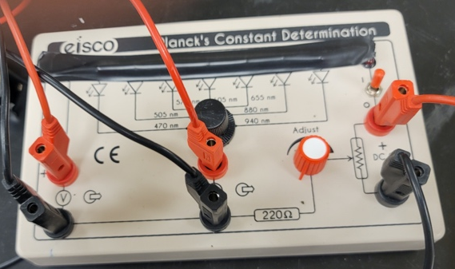
Fig. 1. Planck’s apparatus. On the left, leads go to a voltmeter. Center leads to an ammeter. Right leads to a power supply set at 9.00Volts. Either the potentiometer on the setup or fine voltage adjust on the power supply can be used to set the voltage applied to the LED.

Experimental setup

- LEDs should be covered with back tape to avoid offsets due to the ambient light.
- Start with the switch on the apparatus (Planck’s box) set to “off” and the potentiometer set to lowest value –all the way “ccw”.
- The apparatus should be connected a power supply set at 9V (approx. is OK). The fine adjustment knob will allow some minor adjustments when needed. Do not touch the current limit knob. 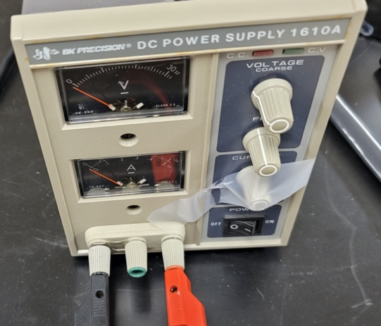

- Select one diode in the apparatus. Turn the switch on on the apparatus (red indicator light goes on). Turning the Adjust knob in the apparatus, you are changing the voltage supplied to the LED. Adjust it upward slowly until you measure 4.00nA in the picoammeter. The associated voltage across the LED is V_{o}. For measuring the current, we are using a Keithly picoammeter that allows you to observe stable currents to about ± 0.05nA. At these small currents you may need to back off touching any wires to observe a stable reading---any motion can change the currents.

I have taped over all the buttons, left this on and in “auto”scale mode for you. YOU DO NOT NEED TO PUSH ANY BUTTONS.
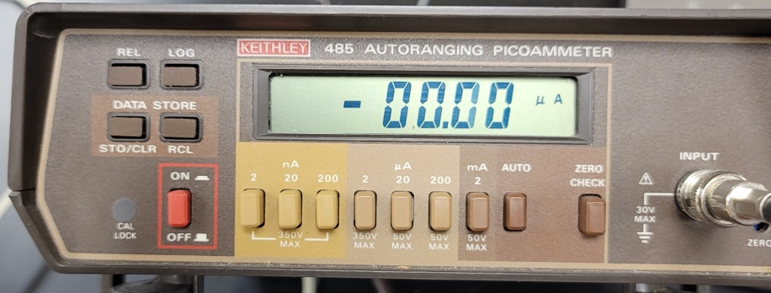

You also have a digital multimeter to measure the voltage across the LED.
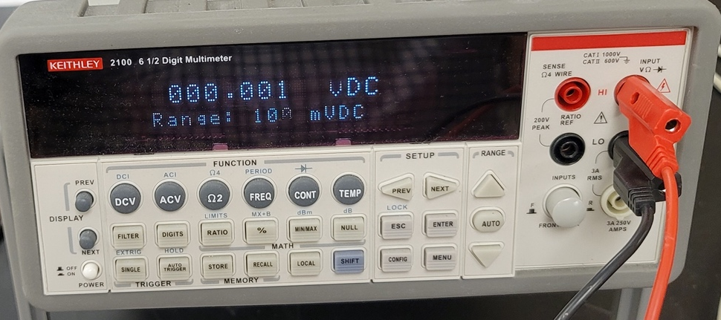

To adjust the voltage you may use either the LED voltage adjust, or the power supply voltage adjust or fine adjust. Any combination of voltage adjust works. The voltmeter also automatically ranges. No need to touch other than lower left power button. Given the precision of our voltmeter and picoammeter, you should never need to exceed a current of 1mA through the diodes. They can probably handle ~50mA, but lets stay away.

- Repeat these steps for all the diodes (making sure you turn the voltage adjust down prior to switching diodes). For each of the diodes measure the threshold voltage (make 4nA occur) and use the data to determine Planck’s constant using an appropriate linear fit.

- Due to the nature of the diode I vs. V curve, as long as we measure currents that are very small we know that we are very close to an appropriate threshold voltage for that diode. We also know that the diode is not heating up appreciably (which they tend to do under normal conditions), so we may assume our diode is operating at approximately room temperature of 293K. (about 20Cº) . We use such a low current!

- You will select one of the diodes to make a detailed I vs V plot (data set) for only that diode. Your data will run from approximately 1 nA, 2nA, 5nA, 10nA, 20nA, 50nA, 100nA, 200nA, 500nA, up to about 1.00mA. The picoammeter should autoscale as you go through this. You may insert more points if you wish, but this covers several decades of data for current vs. voltage for one of the LEDs.

Analysis
- For Planck’s constant, you will plot data as V_{o} (voltage threshold) vs. ν (frequency in Hz). A simple model would indicate that:
eV_{o} = hν

The slope of the plot will yield Planck’s constant in eV s. This works fairly well, except this equation indicates that there should be a y-intercept equal to zero, and in reality there is an offset. This is identical to the situation and equation used for the photoelectric effect, except there we had an offset on the intercept due to the material work function. At the very low currents we use to measure threshold any offset current can throw off V_{o}. In short, while we get a good value for Planck’s constant, the threshold voltage needs to be fixed subtracting the y-intercept value
V_{Threshold}=V_{o} –V_{intercept}

Where V_{o} is the value you have measured as “turn on”, and the intercept is an offset due to most likely thermal emission (or ? ). This is merely a sidenote that brings your measured value of threshold voltages into alignment with typical values seen as “turn on voltages” for various LEDs. See for example the reference linked below.

- Next (now that you have Planck’s constant from step 1) plot an I vs V curve (see page 45 for a reference http://courses.washington.edu/engr100/uwstem/LED.pdf).

$$I_{d}=I_{do}\left(\exp\left(\frac{qV}{2kT}\right)-1\right)+I_{p}$$
The current I_{d} is the measured current through the diode, the constant out front, I_{do,} depends on the material properties of the LED (most notably the band gap), k is Boltzmann’s constant, q is the charge of an electron, and T is the temperature in Kelvins. This equation is often referred to as the Shockley equation or ideal diode equation (do LED’s behave ideally—why or why not).

I’ve looked at several other references and see that the diode equation (Shockley equation) should be written in this case as follows

$I=I_{do}\left(\exp\left(\frac{qV}{ηkT}\right)-1\right)+I_{p}$

- In this equation I is the measured current through the diode while V is the voltage across the diode.
- I_{do} is the reverse saturation current, but you can think of as simply an amplitude here. This must depend on the specific bandgap of the material and other geometric and physical parameters.
- q is the charge “e” here.
- k is Boltzmann’s constant
- T is the temperature (assume Room)
- And I_{p} accounts for any current offset due to either photoemission (light) or thermionic emission (heat).
- η is called the “ideality” factor and depends on specific properties of the semiconductor material properties making up the diode. Typical values range from 1 to 2.

You will use I vs V to fit and determine I_{do}, η and I_{p}.

$I=I_{do}\left(\exp\left(\frac{qV}{ηkT}\right) \right)+{(I}_{p}-I_{do})$

I’ve rearranged the equation so it can be fit to a function of the form y = y_{o} +A exp(R_{o}x) using Origin this comes under the fit functions “exponential” and “exponential”. You may use any fitting program. Using your results from the fit you should be able to determine these three constants. You can use room temperature of 293K. If you know “y_{o}” and “A” you can determine I_{p} and I_{do}. R_{o} can be used to determine η. You will report all three values with uncertainties determined from fitting.

Below are some origin screenshots to bring up the correct fitting function and dialog box. You can use other fitting programs if you are comfortable with obtaining the same information.
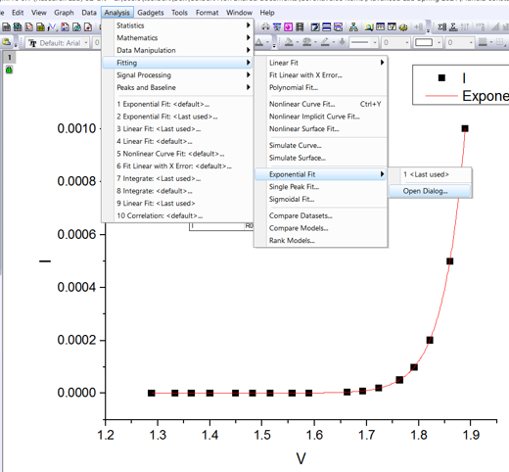

Fig. 2 Origin fitting menu to the exponential style function sets. The plot must be displayed to bring up the fitting menus. Enter the “open dialog” mode.

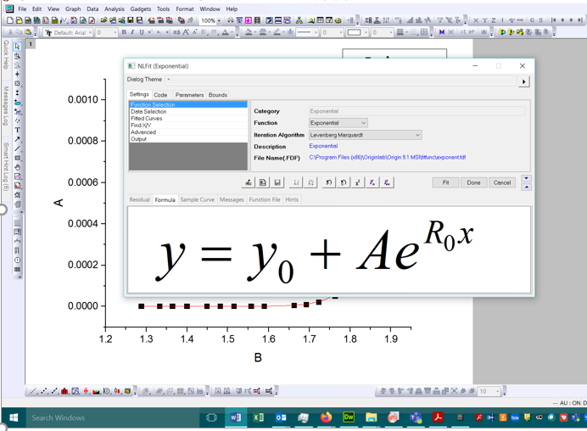
Fig. 3. Getting to precise origin fit function for this task. Note the “formula” tab is highlighted, and within the “exponential” category we have selected the “exponential” function.

Additional comments:
- kT/q is approximately 25 mV, but you will calculate it precisely. This value is small compared to the voltages (qV_{o} or perhaps qV_{threshold}) we use. Because of this, any changes in voltage near threshold (which are in the 1-3 V range) will send the current screaming up due to the exponential. For each additional ~25mV the current increases by “2.7182821828…”
- The band gap energy is buried inside I_{do} and has a factor like exp(-V_{gap}/kT). But these are all constants. When V across the diode is small, the current is small. When V reaches about the same as the gap, then the diode turns on---and only in this region do we first start to see big changes in the current.
- There is no perfect definition for “threshold” out there. For reasons I’ve explained, being off by a couple tenths of a volt (not much) can change currents quite dramatically. If one used 1.00mA instead of 4.00nA---the results would not be very different from what we get at (our method is better though--- )

Part 2) Photoelectric effect experiment

The photoelectric effect works in a very similar manner to the LED lab in part 1. Rather than an LED, we use an evacuated tube. When light hits the photosensitive material (the Anode), electrons are emitted with a range of kinetic energies. When a negative voltage is applied to the cathode of just the right amount, then no electrons reach the cathode. So we will be measuring the stopping voltage, V_{o} required to make the photocurrent just become zero. This determines the initial kinetic energy of the electrons. We do this for several different incident light energies (wavelengths).

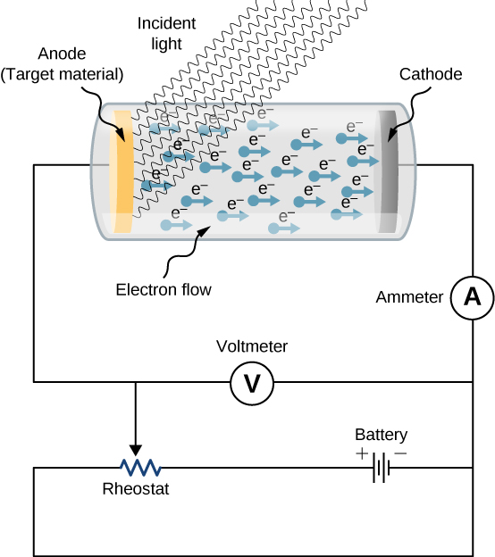
https://i.stack.imgur.com/ovtud.jpg

The governing equation is:

KE= hν- ϕ 1.

|eV_{o}|= hν- ϕ 2.

Measuring stopping potential vs. frequency (plot energy in electron volts vs frequency), we can determine Planck’s constant and the work function. In Eq. 2, the left side (Kinetic energy) is always positive.

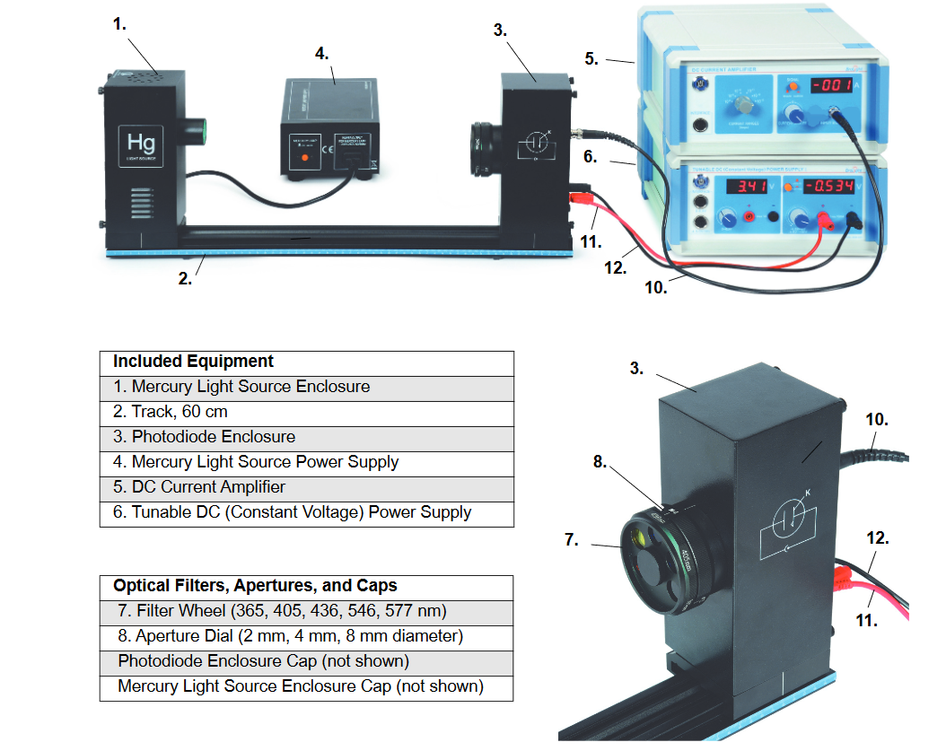

The photodiode tube is mounted in a housing on a track. The leads go to a current preamplifier much like the picoammeter used for the LED experiment and is well matched to the tube used here (not an LED). The light source is a mercury lamp which outputs several different wavelengths. The front aperture of the tube has an adjustable aperture (opening). We’ll use the 2mm opening. This allows the narrowest beam angle through to the narrow bandwidth filters (narrow optical filters work better if light is incident normally).

The filters can adjust to view either 365, 405, 436, 546, 577 nm emission lines from the mercury lamp. You will record a “stopping potential” for each of these wavelengths (which will need to be converted to frequencies).

THE LAMP MUST BE ALLOWED TO WARM UP IN ORDER TO HAVE A STEADY OUTPUT. Approximately 10 minutes is good. Do not stare into the light. Since you will be monitoring as close to “zero” current as possible, it matters very much if the lamp signal is changing while making your measurement. This is what Pasco did incorrectly in an effort to cherry pick data—failure of lamp warmup yields sloppy data. It is not possible to get as precise or accurate data as Pasco’s fudged/sloppy oops data taken whilst not letting the lamp warm up. I know this---I tried. “Many Bothans ….to bring you this information………..”

Equipment instructions:
- You will turn on the mercury lamp with the cover off, and allow to warm up. The lamp gets hot, so the cover must be removed.
- The output of the phototube should go to the current amplifier (we’ll use Pasco’s), and be set on the 10⁻¹³A scale. You will be observing current on this scale and will set the voltage adjustment to reduce the current to zero.
- With the cap on the phototube—push signal button to “Calibrate” on the DC ammeter. Zero it. Pop up the button from Calibrate to Measurement mode.
- Remove the cap from the phototube.
- Check to see if room lights or rubbing the cable change the signal.
- Set inner circle to 2mm aperture.
- The voltage power supply should be on the -4.5Volt-0 scale.
- For each wavelength, dial up the stopping potential from zero.
  - You may play with changing the voltage to examine what happens as you change voltage.
  - Always start from zero voltage to take your data.
- Cycle the outer wavelength dial from 0nm through all wavelengths
  - While doing so determine the stopping potential for each wavelength (dial up and measure).
  - Click, reset, do again.
- Analysis---you should know how to make this plot and determine both Planck’s constant and also the work function for the material in the tube.

